DATE: 06.12.2019
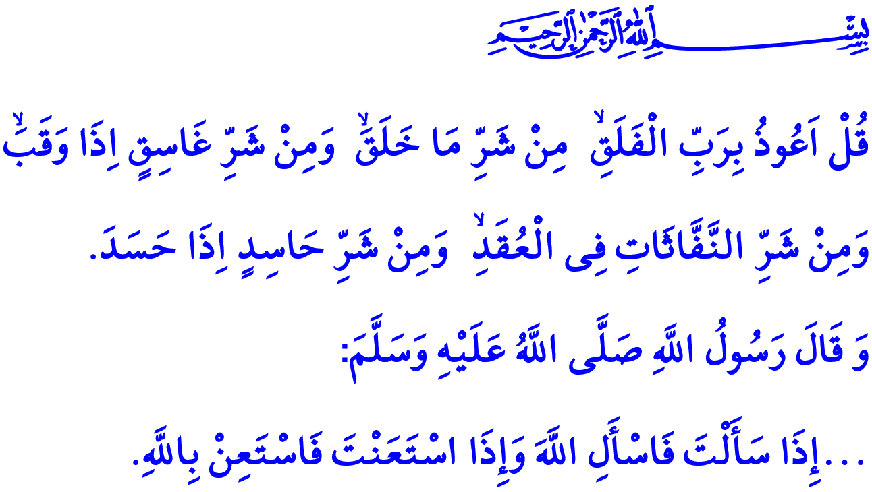 FALSE BELIEFS AND SUPERSTITIONS
Honorable Muslims!
One day the Prophet Muhammad (saw) was on a road trip with his paternal uncle's son Abdullah ibn Abbas and he gave him the following advices: “O young man, I shall teach you some words of advice. Be mindful of Allah and Allah will protect you. Be mindful of Allah and you will find Him in front of you. If you ask, then ask Allah alone; and if you seek help, then seek help from Allah alone. And know that if the nation were to gather together to benefit you with anything, they would not benefit you except with what Allah had already prescribed for you. And if they were to gather together to harm you with anything, they would not harm you except with what Allah had already prescribed against you...”
Dear Believers!
The sublime religion, Islam, points out for all people the truths of faith and the paths to peace in this world and in the Hereafter. Islam wants people to worship, rely on, seek refuge in the mercy of, and ask help from Allah (swt) only. Accordingly, it rejects all false beliefs and superstitions. Islam regards it as a great sin to exploit people's feelings and values by taking advantage of their lack of knowledge and desperateness. People, however, have from time to time failed to pay attention to such principles of the religion and found themselves hoping for help from fortunetellers, sorcerers, soothsayers, magicians, and mediums.
Dear Muslims!
It is against the essence of Islam to assert claims about, and hope for help from practices such as, predicting the future, changing people's fate, bringing luck, and offering cures. For the future and unknown is known to Allah (swt) only. For He alone is the Most Powerful over all things. For He is the One, Who provided us every piece of food we eat and every drop of water we drink. For in Him alone rests the remedy to sorrows, the cure to diseases, and the solution to problems. For He is the One Who at all times oversees us and respond to our heartfelt entreaties and sincere prayers.

Dear Believers!
It is never approvable to make plans about the future by placing one's hopes on fortunetelling, sorcery, and soothsaying while we have faith in Allah (swt) and on Him we rely. It would be against the Islamic standpoint to suggest that one has obtained knowledge of people's fates through observing the movements of stars. It would also be against the Islamic faith to attribute mystery and bad omen to numbers, days, months, and objects that have no ability and power to do or change anything. Among such practices prohibited by Islam are to view a piece of bead as holy for thinking it protects against evil, tying a piece of cloth to a tree, and throwing away coins into a pool of water in the hope that they bring good luck.
Dear Muslims!
Let us think for a moment. Why are those people, who claim to find solutions to other people's problems through such illegitimate means as sorcery and magic, not able to find solutions to their own problems? Why are those people, who exploit other people's hopes through lies that they know what will happen in the future, not able to find the right path with the knowledge they claim to have? Why are those people, who deceive other people by telling them that they have cure for their illnesses, not able to use the same cure for their own illnesses?
Dear Believers!
The Almighty Allah (swt) states in the Surah al-Falaq I have recited at the beginning of the khutbah, “Say, “I seek refuge in the Lord of daybreak, from the evil of that which He created, and from the evil of darkness when it settles, and from the evil of the blowers in knots, and from the evil of an envier when he envies.”
Let us then not spoil our clean human nature, created by Allah (swt) as fit for faith and inclined to do good, with false beliefs and superstitions. Let us strengthen our faith, which is our most precious treasure, with sincere feelings and our intentions with authentic religious knowledge. Let us make it a principle for a peaceful life to work and earn our livelihood through legitimate means, get treatment when ill, and seek for reasons to rely our efforts on. Let us not fall for hope-mongers who promote shortcutting the efforts through illegitimate means to earn a living. Let us ask Allah (swt) only for success, salvation, cure, and providence in this world and in the Hereafter. Let us always believe that He does not leave our prayers unresponded when uttered in a heartfelt manner.

Tirmidhi, Sifat al-Qiyamah, 59; Ibn Hanbal, I, 293.
Falaq, 113/1-5. General Directorate of Religious Services

